**7. ReactJS-HOL**

**FOLDER STRUCTURE**

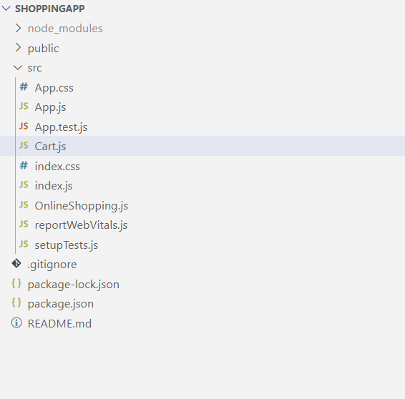

**Cart.js**

import React, { Component } from 'react';

class Cart extends Component {

  render() {

    return (

      <div style={{ border: '1px solid #ccc', margin: '10px', padding: '10px' }}>

        <h3>Item: {this.props.Itemname}</h3>

        <p>Price: ₹{this.props.Price}</p>

      </div>

    );

  }

}

Cart.defaultProps = {

  Itemname: "Unknown Item",

  Price: 0

};

export default Cart;

**OnlineShopping.js**

import React, { Component } from 'react';

import Cart from './Cart';

class OnlineShopping extends Component {

  constructor(props) {

    super(props);

    this.state = {

      items: [

        { id: 1, name: 'Laptop', price: 55000 },

        { id: 2, name: 'Mobile', price: 15000 },

        { id: 3, name: 'Headphones', price: 2000 },

        { id: 4, name: 'Keyboard', price: 1000 },

        { id: 5, name: 'Mouse', price: 800 }

      ]

    };

  }

  render() {

    return (

      <div>

        <h1>🛒 Online Shopping Cart</h1>

        {this.state.items.map(item => (

          <Cart key={item.id} Itemname={item.name} Price={item.price} />

        ))}

      </div>

    );

  }

}

export default OnlineShopping;

**App.js**

import React from 'react';

import OnlineShopping from './OnlineShopping';

function App() {

  return (

    <div className="App">

      <OnlineShopping />

    </div>

  );

}

export default App;

**OUTPUT**

